LCM2025 - The UKCEH Land Cover Map for 2025

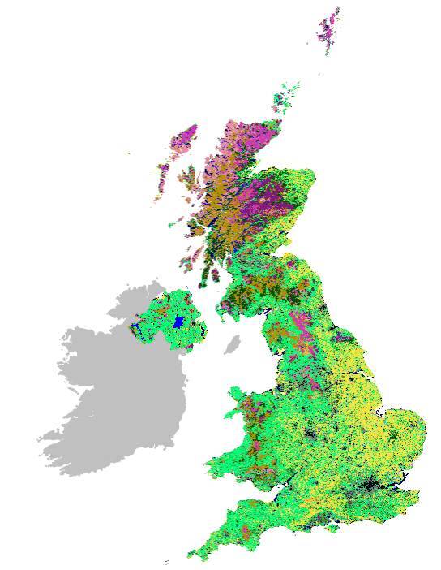
Version | Date | Updates
1.0 | 12th August 2026 | First version
1.1 | 12th October 2026 | Second version – doi’s for additional products added; note about land cover change added to LCM stats section

Purpose
This is the user guide for the UKCEH Land Cover Map for 2025, LCM2025. The LCM2025 product consists of eight datasets, three each for Great Britain and Northern Ireland comprising a 10 m dataset of classified pixels, a vector dataset of classified land parcels, a 25 m pixel dataset of rasterised land parcels and a statistics data set. A further 1 km summary raster product covering both Great Britain and Northern Ireland is also available. Appropriate use of complex data requires a deeper understanding than structure and content. We therefore describe data production, validation and data accuracy. Our goal is to help users make informed decisions regarding the application of UKCEH LCM data in their current and future work.
Contents
Important note regarding Land Cover Change 3
Introduction 4
UK CEH Land Cover Classes and BAP Broad Habitat Classes 4
Dataset descriptions 6
10 m Classified Pixel datasets 6
Land Parcel datasets 6
25 m Pixel Rasterised Land Parcel datasets 8
1 km raster products 9
LCM statistics 10
Material and Methods 11
Seasonal Composite Images 11
Context Rasters 11
Classification Scenes 12
The UKCEH Land Parcel Spatial Framework 13
Bootstrap Training 13
Random Forest classification 14
Product validation 14
Known Issues 15
Citing LCM2025 15
Acknowledgements 15
References 16
Appendix 1. Notes on UKCEH Land Cover Classes 18
Appendix 2. Biodiversity Action Plan (BAP) Broad Habitats 23
Appendix 3. Full list of datasets for UKCEH LCM2025 26
Appendix 4. Correspondence matrices for UKCEH LCM2025 27
Appendix 5. Traditional colour recipe for displaying UKCEH Land Cover Classes 28
Appendix 6. Recommended colour recipe for displaying UKCEH Land Cover Classes colour blind friendly 29
Glossary
Bootstrap Training: A method that automatically selects training observations from a historical land map. Bootstrap Training datasets are used by a Random Forest to classify Classification Scenes.
Context Raster: A multi-band raster with contextual information, such as terrain, coastal and urban proximity. Context Rasters are combined with Seasonal Composite Images to create Classification Scenes.
Classification Scene: A multi-layer raster comprising spectral information from a Seasonal Composite Image and Context Rasters. Classification Scenes are classified to yield a pixel land cover classification.
Seasonal Composite Image: A multi-band raster representing spectral observations across four seasons. These are designed to provide temporal, phenological information that a classifier can use to differentiate vegetation types.
UKCEH Land Cover Classes: A set of land cover classes defined by UKCEH, derived from the UK Biodiversity Action Plan Broad Habitats (Jackson et. al. 2000).
UKCEH Land Parcel Spatial Framework: A database of land parcel objects derived from generalising national cartography in order to remove unnecessary detail. All UKCEH LCM Land Parcel datasets use this spatial framework.

Important note regarding Land Cover Change
As part of the continuous development of the Land Cover Map series, slightly different methods have been used to generate the recent annual Land Cover Maps. Consequently, changes between land cover maps will include both real changes in land cover and changes due to classification method. Users should be aware of this when interpreting land cover change derived from LCM. This is particularly noticeable currently as the LCM production methods are undergoing an overhaul, to improve accuracy. The intent is then to reprocess the whole LCM time-series to produce a consistent dataset with robust, reliable change data.

Introduction
In this document we capitalise the first letters of some specific terminology. In most cases the meaning of these terms should be clear from the text, but for extra clarity a glossary is provided for these capitalised terms. Land cover types are also capitalised and/or italicised; these are described in appendices.
Land Cover Map 2025 (LCM2025) is the thirteenth UK land cover map produced by UKCEH joining: LCM1990, LCM2000, LCM2007, LCM2015, LCM2017, LCM2018, LCM2019, LCM2020, LCM2021, LCM2022, LCM2023 and LCM2024. Land cover is given as 21 UKCEH Land Cover Classes based on Biodiversity Broad Habitats (BAP, see Jackson 2000).
LCM2025 was created by classifying Sentinel-2 satellite data combined with a series of context layers (designed to reduce spectral confusion). The data stack, created by combining the satellite data and context layers, is then classified using a Random Forest classifier and a training data set largely derived from previous LCM data.
The UK is currently undergoing substantial land cover change, in particular new tree planting, and commercial, industrial and housing developments. Considering these changes, we have updated some of the class descriptions and notes given in Appendix 1, so existing users of LCM should review these amendments and clarifications. [Amendments in Appendix 1 are in red].
Historically, because of high costs associated with labour intensive image pre-processing and gathering training data, there was a lag of approximately ten years between UKCEH LCMs. However, using new techniques we are able to produce new land cover maps annually. These methods are still evolving, and we seek continuous improvements. We are currently reviewing LCM methods with the aim of improving accuracy, as well as consistency over time, with the intention of re-producing the whole LCM time-series. This will maximise temporal consistency, comparability and the potential for change detection, which is a fundamental goal for our land cover mapping. A benefit of annual production is that it helps to differentiate errors from real-world change. Most classification errors are random in space and time, so should not occur at the same location year-after-year. With a rich time-series of land cover maps random errors will flicker on and off, whilst real land surface changes will persist. We therefore anticipate that as the annual series matures, UKCEH annual land cover maps will become an essential tool for monitoring the state and change of the UK countryside and support a wide range of environmental objectives
Formal validation of LCM2025 gives an overall accuracy of 85.9%, at full thematic detail.

UK CEH Land Cover Classes and BAP Broad Habitat Classes
At the turn of the century, conservation and regulatory agencies had reporting obligations under the UK Biodiversity Action Plan (BAP, Jackson et al. 2000) and were co-funding stakeholders of LCM2000 and LCM2007. Therefore, the 21 UKCEH Land Cover Classes are closely related to Biodiversity Action Plan (BAP) Broad Habitats, but they are not identical. BAP Broad Habitats were designed for field-based detection by botanists rather than via satellite remote sensing, therefore there are slight deviations. Agencies no longer have reporting obligations under the UK BAP, but we retain the land cover descriptions to preserve consistency and comparability with earlier products.
Describing complex land cover and habitat types that share similar nomenclatures and similar (but not equal) meanings precisely with words can ambiguous. In most cases we could refer to UKCEH Land Cover Classes and BAP Broad Habitats synonymously without causing confusion, however we sometimes we need to contrast them. To reduce ambiguity regarding land cover and habitat descriptions, we therefore italicise UK BAP Broad Habitats when explicitly referring to these. At all times when referring to a defined class (UKCEH or UK BAP) we will begin each element with a capital letter. For example: Improved Grassland refers to the UKCEH Land Cover Class, Improved Grassland the BAP habitat.

Table 1. Relationship between UKCEH Aggregate classes, UK BAP Broad Habitats (Jackson 2000, highlighted in green) and UKCEH Land Cover class and associated integer identifiers. Additional notes on the on the relationships between UKCEH Land Cover Classes and UK BAP Broad Habitats are given in Appendices 1 and 2 together with satellite-based mapping considerations.
UKCEH Aggregate Class (AC) | AC Identifier | UK BAP Broad Habitat | UKCEH Land Cover Class | LC Identifier
Broadleaf woodland | 1 | Broadleaved mixed and yew woodland | Deciduous woodland | 1
Coniferous woodland | 2 | Coniferous woodland | Coniferous woodland | 2
Arable | 3 | Arable and horticulture | Arable | 3
Improved grassland | 4 | Improved grassland | Improve grassland | 4
Semi-natural grassland | 5 | Neutral grassland | Neutral grassland | 5
Semi-natural grassland | 5 | Calcareous grassland | Calcareous grassland | 6
Semi-natural grassland | 5 | Acid grassland | Acid grassland | 7
Semi-natural grassland | 5 | Fen marsh and swamp | Fen | 8
Mountain, heath and bog | 6 | Dwarf shrub and heath | Heather | 9
Mountain, heath and bog | 6 | Dwarf shrub and heath | Heather grassland | 10
Mountain, heath and bog | 6 | Bog | Bog | 11
Mountain, heath and bog | 6 | Inland rock | Inland rock | 12
Saltwater | 7 |  | Saltwater | 13
Freshwater | 8 | Standing open water and canals | Freshwater | 14
Freshwater | 8 | Rivers and streams | Freshwater | 14
Coastal | 9 | Supralittoral rock | Supralittoral rock | 15
Coastal | 9 | Supralittoral sediment | Supralittoral sediment | 16
Coastal | 9 | Littoral rock | Littoral rock | 17
Coastal | 9 | Littoral sediment | Littoral sediment | 18
Coastal | 9 | Littoral sediment | Saltmarsh | 19
Built-up areas and gardens | 10 | Built-up areas and gardens | Urban | 20
Built-up areas and gardens | 10 | Built-up areas and gardens | Suburban | 21

Some users do not require the full thematic detail of UKCEH Land Cover Classes so we also provide generalised land cover UKCEH Aggregate Classes in our Land Parcel product. Table 1 shows the relationship between UKCEH Land Cover Classes and For Aggregate Classes, with the UK BAP Broad Habitats. Usually there is a one-to-one relationship between UK BAP Broad Habitats and derived UKCEH Land Cover Classes. However, the UK BAP Standing water and Canals and the UK BAP Rivers and Streams are represented by a single UKCEH Land Cover Class, Freshwater. There is not a UK BAP for saltwater, but we separate saltwater and freshwater when possible, so include a UKCEH LCM Saltwater class. In two cases, we have found it appropriate to split UK BAP Broad Habitats. The UK BAP Dwarf Shrub and Heath class is split into UKCEH Land Cover Classes Heather and Heather grassland. The UK BAP Built up Areas and Gardens class is split into UKCEH Land Cover Classes Urban and Suburban. Fuller details are given in Appendices 1 & 2.

Dataset descriptions
LCM2025 includes three geospatial datasets specific to Great Britain and Northern Ireland (Table 2), with a further 1 km summary raster data product covering both Great Britain and Northern Ireland. Appendix 3 gives the official dataset name for each of these digital holdings.

10 m Classified Pixel datasets
The 10 m pixel datasets are produced from multiple classified Classification Scenes that are compiled to create a single mosaic of national cover. The Random Forest classifier derives a probability of membership for each class. The class with the highest is the most likely land cover. The first band of the 10 m pixel dataset is an integer representing the most likely UKCEH Land Cover Class. The second band is the probability that was associated with this result; this gives an indication of the confidence of the classification (Figure 1). Zero values in this data set represent unclassified/masked pixels.
Unlike pixels of the 25 m Rasterised Land Parcel dataset, the 10 m Classified Pixels have not been generalised by combination with the UKCEH Land Parcel Spatial Framework. This preserves intricate features of the landscape such as narrow linear features and small patches of habitat that fall below the 0.5 hectare minimum mappable unit (MMU) of the UKCEH Land Parcel Spatial Framework. We anticipate that this extra detail will be of interest and useful but please note the formal validation exercises were performed against the 25 m Rasterised Land Parcel dataset, not the 10 m Classified Pixels.
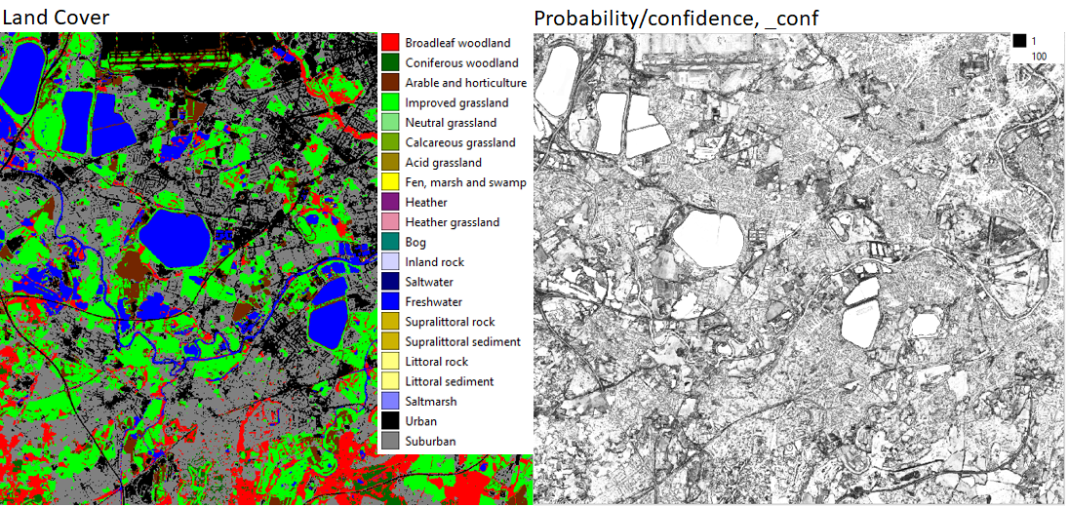
Figure 1. Left; 10 m classified pixels. Right; the probability associated with each classified pixel; this is an indicator of classification confidence.

Land Parcel datasets
The Land Parcel datasets are the result of intersecting the 10 m Classified Pixel datasets with the UKCEH Land Parcel Spatial Framework to generate land parcel attributes (Figure 2, Table 3).
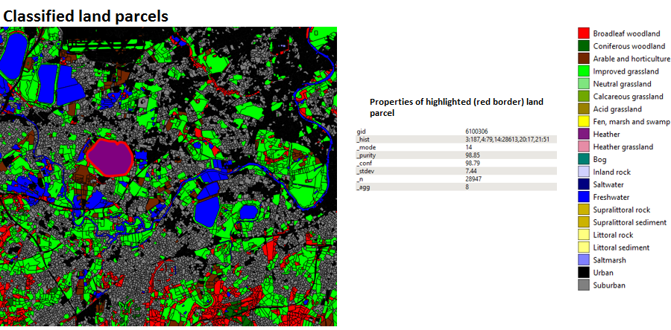
Figure 2. Classified land parcels and properties of the highlighted (red border) land parcel.
Table 2. UKCEH LCM product suite details (metadata).
 | Great Britain, GB |  | Northern Ireland, NI
Coordinate System | British National Grid. EPSG: 27700 |  | TM 75 Irish Grid. EPSG: 29903
Land Parcel Products
Number of parcels | 6741280 |  | 902252
8-bit Raster Products
Raster Extent, metres. (East min, East max, North min, North max) | (0, 700000, 0, 1300000) |  | Truncated Irish Grid to: (180000, 400000, 300000, 500000)
Product Name | Classified Pixels | Rasterised Pixels | Classified Pixels | Rasterised Pixels
Pixel resolution | 10 m | 25 m | 10 m | 25 m
Number of bands | 2 | 3 | 2 | 3

Table 3. UKCEH LCM Land Parcel product attributes for LCM2025.
UKCEH LCM attribute name | Example | Description
gid | 10079 | This is a unique identifier for the land parcel.
_hist | 2:3, 11:361 | This describes the frequency of 10 m pixels per UKCEH land cover class encountered in a land parcel given as a list of tuples <left>:<right> separated by commas. The figure to the left of the colon per tuple represents the UKCEH Land Cover Class identifier, to the right the frequency of occurrence.
_mode | 11 | This is the most frequently occurring (modal) land cover type.
_purity | 99.06 | This is the percentage of the modal land cover class over the total number of pixels (_n) encountered.
_conf | 93.88 | This when combined with _purity helps to understand classification confidence. It is the mean polygon value of the class membership probability for each pixel, rescaled to the range of 0 to 100.
_stdev | 9.51 | This is the standard deviation of _conf.
_n | 319 | This is the total number of 10 m pixels intersecting the land parcel.
ogc_fid | 415793 | Unique parcel identifier created during the production of the vector data set. It is preferable to use the gid attribute rather than these attributes.

25 m Pixel Rasterised Land Parcel datasets
These are the result of rasterising the Land Parcel dataset into 25 m pixels, with the pixel origin matching the origin of the British National Grid (for Great Britain) or the Irish National Grid (for Northern Ireland). Three attributes are carried from the Land Parcel datasets, giving a 3-band raster. Band 1 is the dominant land cover _mode; band 2 is _conf; and band 3 _purity (see Figure 3).
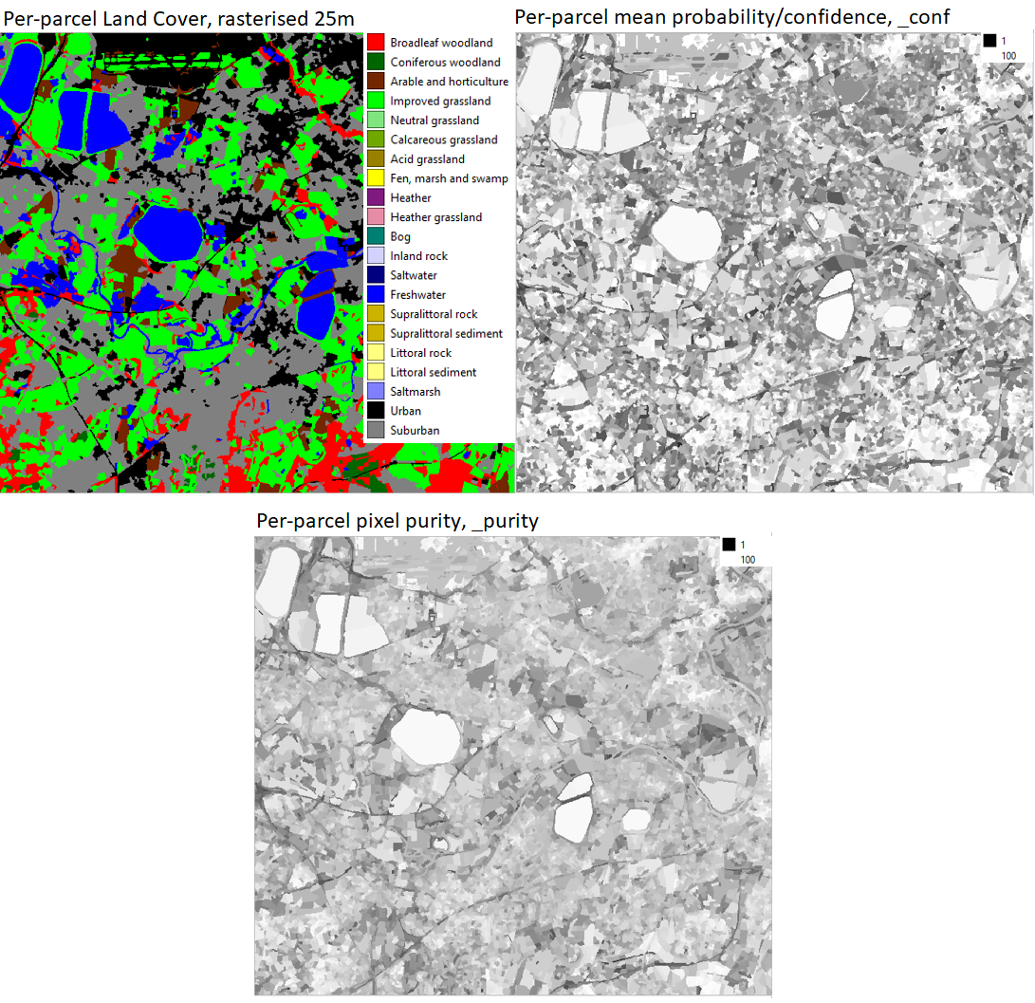
Figure 3. Left top, rasterised land parcels at 25 m pixel resolution. Right-top mean parcel most likely land cover probability (_conf). Bottom per parcel purity (_purity).

1 km raster products
The 1 km products for LCM2025 were created by summarising the LCM2025 25 m raster data set to produce percentage cover for each class and to identify the dominant (most widespread) class in each 1 km pixel. The products at 1 km are (see Table 1 for details of the 21 target Land Cover Classes and the 10 aggregate classes):
- Dominant cover at 1 km for LCM2025 target classes (1 band)
- Dominant cover at 1 km for LCM2025 aggregate classes (1 band)
- Percentage cover at 1 km for LCM2025 target classes (21 bands)
- Percentage cover at 1 km for LCM2025 aggregate classes (10 bands)
For the percentage cover products, integer values are reported, so the rounding of each value means that in some cases the sum of all the layers may be slightly above or below 100. Around the coast the values will be sum to less than 100 reflecting the proportion of mapped area in the 1 km square. One 1 km x 1 km pixel covers the area of 1600 25 m pixels, consequently, a land cover type must cover more than sixteen 25 m-pixels to exceed 1% of the 1 km pixel area, and hence have a percentage cover value in the 1 km percentage cover data sets.

LCM statistics
This is a new data set that summarises the land cover extent, as given by LCM2025, for a range of geographical units. The land cover statistics are provided as tabular data in comma separated value (csv) files, which can be opened in packages like Microsoft Excel, and as spatial data in Geopackage files (.gpkg files) for use in geospatial software.
LCM statistics are provided to enable wider use of the LCM data and also as part of the ongoing LCM improvement efforts, as the county level data will be used to help identify where classes are being missed, or under-estimated.
Important information regarding land cover change - If comparing LCM2024 and LCM2025 statistics, users should be aware that slightly different methods have been used to generate the recent annual Land Cover Maps. Consequently, changes between land cover maps will include both real changes in land cover and changes due to classification method. Users should be aware of this when interpreting land cover change derived from LCM. This is particularly noticeable currently as the LCM production methods are undergoing an overhaul, to improve accuracy. The intent is then to reprocess the whole LCM time-series to produce a consistent dataset with robust, reliable change data.
To allow comparison with other data sources, the geographical units use the Office for National Statistic (ONS) boundaries areas, with statistics produced for:
- UK countries, using: Countries (December 2024) Boundaries UK BGC | Open Geography Portal
- UK counties and Unitary Authorities (UA) using: Counties and Unitary Authorities (December 2024) Boundaries UK BGC | Open Geography Portal
- English regions, using: Regions (December 2024) Boundaries EN BGC | Open Geography Portal
All regions include land cover extents in m² and percentage areas. The county and Unitary Authority areas include area in hectares, whilst the larger geographies, regions and countries, give values in km².
The tabular data and the spatial data both maintain a set of attributes from the original ONS data files, plus a series of LCM2025-based attributes for each class.
Attributes inherited from the original ONS files:
- Fid – polygon number
- *CD - Code number – varies depending on data set; CTRY24CD – country code; CTYUA24CD – county and unitary authority code; RGN24CD – regional code
- *NM & *NMW – Name – varies depending on data set; CTRY24NM – country name; CTRY24NMW – country name in Welsh; CTYUA24NM - county and unitary authority name; CTYUA24NMW - county and unitary authority name in Welsh; RGN24NM – regional name.
- BNG_E, BNG_W – British National Grid coordinates in Eastings (_E) and Westings (_W) for polygon centroid.
- LONG, LAT – Longitude and latitude for polygon centroid in degrees.
- GlobalID – unique ONS identifier.
- SHAPE_area; SHAPE_length – polygon area and perimeter in meters.
Additional attributes for LCM2025 data sets:
- LCM2025_* - where * denotes the class number (as given in Table 1). Pixcount gives the number of pixels for the geographical unit for each class. Each pixel is 10 m x 10 m, these values are included for completeness, but it is anticipated that most users will use the areal units.
- LCM_pixcount – this gives the total number of pixels for each of the geographical units (i.e. each polygon), and is used in the calculation of the percentage values.
- *_area_m2 - area in m² for each class (* denotes abbreviated class name).
- *_area_km2 - area in km² for each class (* denotes abbreviated class name).
- *_percent - percentage area covered by each class (* denotes abbreviated class name).

The LCM statistics use the 10m raster data set, other data sets e.g. the 25m data set would give different results. The 10m data are used as the basis of the statistics as they provide the highest resolution spatial data. This will be reviewed for future iterations, especially with respect to how we produce a data set that can be compared with the full LCM time-series.
The data set are UK-wide, and use the British National Grid projection (EPSG: 27700); this reflects the underlying ONS data.

Material and Methods

Seasonal Composite Images
Seasonal Composite Images for classification were derived from Google Earth Engine using a commercial account. Sentinel-2 surface reflectance values were resampled to 10 m pixel resolution and median reflectance was computed for four time periods: January-March, April-June, July-September, and October-December, using ten Sentinel-2 bands 2, 3, 4, 5, 6, 7, 8, 8a, 11, and 12 (after Carrasco et. al., 2019), see Table 4. There were occasional seasonal gaps in the Seasonal Composite Images due to persistent cloud in an image compositing period which were represented by null data. Our classification algorithm will tolerate partially complete spectral information when there are gaps in a particular season.
Table 4. Sentinel-2 spectral bands and spatial resolutions.
Sentinel-2 Band | Central wavelength (µm) | Resolution (m)
Band 1 - Coastal aerosol | 0.443 | 60
Band 2 - Blue | 0.490 | 10
Band 3 - Green | 0.560 | 10
Band 4 - Red | 0.665 | 10
Band 5 - Vegetation red edge | 0.705 | 20
Band 6 - Vegetation red edge | 0.740 | 20
Band 7 - Vegetation red edge | 0.783 | 20
Band 8 - Near infra-red | 0.842 | 10
Band 8A - Vegetation red edge | 0.865 | 20
Band 9 - Water vapour | 0.945 | 60
Band 10 - Short wave infrared - cirrus | 1.375 | 60
Band 11 - Short wave infrared | 1.610 | 20
Band 12 - Short wave infrared | 2.190 | 20

Context Rasters
Spectral confusion can occur between different land cover types that have similar spectral properties. For example, bare rocks in the littoral coastal zone lack significant vegetation, so too do exposed mountain rocks and sealed urban surfaces. Spectrally these surfaces can appear very similar when viewed from space and extra detail is required to differentiate them. We used 10 m Context Rasters to resolve a range of confusion types. For Great Britain, the 10 m Context Rasters were:
- Height, derived from the NEXTMap® terrain product from Intermap® Solutions.
- Aspect, derived from the NEXTMap® terrain product from Intermap® Solutions.
- Slope, derived from the NEXTMap® terrain product from Intermap® Solutions.
- Distance from the nearest building, derived from Ordnance Survey open data.
- Distance from road, derived from Ordnance Survey open data.
- Distance from tidal water, derived from Ordnance Survey open data.
- Distance from freshwater, derived from Ordnance Survey open data.
- A foreshore binary mask, derived from Ordnance Survey open data.
- A woodland binary mask, derived from Ordnance Survey open data.
- A saltmarsh binary mask, derived from Environment Agency, Scottish Government and Natural Resources Wales open data.
For Northern Ireland 10 m Context Rasters were:
- Height, derived from the NEXTMap® terrain product from Intermap® Solutions.
- Aspect, derived from the NEXTMap® terrain product from Intermap® Solutions.
- Slope, derived from the NEXTMap® terrain product from Intermap® Solutions.
- An urban binary mask derived from open data of the Northern Ireland Statistics and Research Agency.
- A distance to coast layer derived from the Ordnance Survey or Northern Ireland open data.
- A distance to freshwater layer derived from the Ordnance Survey or Northern Ireland open data.
- A distance to road layer derived from the Ordnance Survey or Northern Ireland open data.
- A foreshore binary mask, derived from Ordnance Survey or Northern Ireland open data.
- A tidal water binary mask, derived from Ordnance Survey or Northern Ireland open data.

Classification Scenes
For Great Britain, a grid of tiles based on a modified version of the Ordnance Survey 100 x 100 km tile grid was created (Figure 4). In total, we classified 32 Classification Scenes comprising full coverage of the GB land surface. Each Classification Scene was trained and classified independently. The approximate 100 x 100 km tile size was chosen as this provides a manageable size for processing. Moreover, if regions were much larger phenological variation due to climatic difference across a Classification Scene could begin to degrade results. Some tiles such as those encompassing the Western Isles, Orkney and Shetland, and Cornwall and the Scilly Isles are larger. These are intentionally enlarged to avoid a sparsity of training data due to the extensive presence of sea in these tiles. Occasionally where tile extents are modified to include specific areas overlap between adjacent tiles do occur.
For Northern Ireland, because of its much smaller area, it was possible to use a single Classification Scene determined by the minimum bounding rectangle of the Northern Ireland land mass (Figure 2). The 40-band Sentinel-2 Seasonal Composite Image was combined with Northern Ireland Context Rasters to produce a 49-band single Classification Scene.
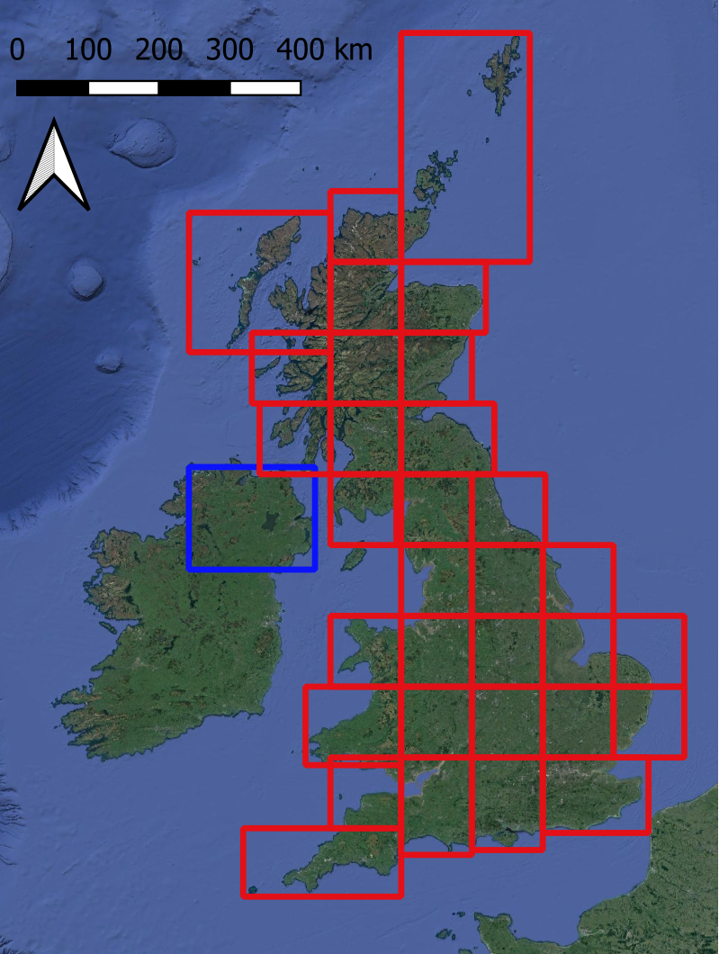
Figure 4. Tiles used for selecting Sentinel-2 Seasonal Composite Images for Great Britain (red) and Northern Ireland (blue).

The UKCEH Land Parcel Spatial Framework
The UK Land Parcel Spatial Framework used for LCM2025 was originally developed for LCM2007 (Morton et. al., 2011) and a modified version was used for LCM2015. We have had to make some minor changes since LCM2015. The land parcel geometries are unchanged, but we have re-ordered database storage and defined new indices to enable faster processing. The consequence of this is that the unique identifiers (the gid attribute) for each land parcel do not match those provided in the LCM2015 Land Parcel dataset. For most users this will have no significance, but for users who wish to compare the new land cover with LCM2015 using parcel identifiers, instead of spatial overlap, this will not be immediately possible.
Land parcels in the UKCEH Land Parcel Spatial Framework have a minimum area of approximately 0.5 hectares, the MMU. The land parcels were derived by generalising national cartography (Morton et. al., 2011; Smith et. al., 2007) and are designed to represent discrete real-world units of land such as fields, parks, urban areas, woodlands, lakes and so forth. It is usual, but not universal, that the land parcels are dominated by a single land cover type. Organising the 10 m Classified Pixels into land parcels helps to reduce classification noise to provide a clean, easier to use product. It also provides a convenient fixed structure for comparing land cover over time for change detection.

Bootstrap Training
Bootstrapping is used to refer to a self-starting process that proceeds without external input. UKCEH have developed an automatic training process for land cover/habitat classification that does not require a fresh collection of (expensive) field-gathered data for classifier training, and we have named the process Bootstrap Training. Land cover and habitat change is usually gradual. Transitions from one land cover or habitat to another typically occur over a number of years. Therefore, recent habitat/land cover maps can be a valuable source of training data for a new map if the original maps are accurate and the update interval of the new map is short relative to target dynamics. When this is true, land cover observations from the historic maps can be used to sample the current satellite image to produce training observations. These can then be used by a RF classifier to yield a classification result, which contributes to the bootstrap for the next map and so forth. Because the historic maps give wall-to-wall coverage they provide a very large number of training observations, which is the key to learning success. Machine-learning algorithms, such as RF, rely on the majority signal to assign class membership, so when the Bootstrap Training set is very large if a minor proportion have changed class (are incorrect) over the refresh interval since these will have little influence on the dominant signal.
The training dataset for UKCEH LCM2025 is derived largely from previous land cover maps. Figure 5 gives an example of a Bootstrap Training dataset and resulting classification result. Crop rotation between arable and improved grassland classes, mean that in some areas this method is less well suited to producing training data for these classes. So, training data for arable and improved grassland classes was supplemented with information from UKCEH Land Cover® plus: Crops data for GB for 2025. Training data for Calcareous grassland was also filtered against soil data (Feeney et al., 2026). The training data can also be supplemented by other data to improve classes where required.
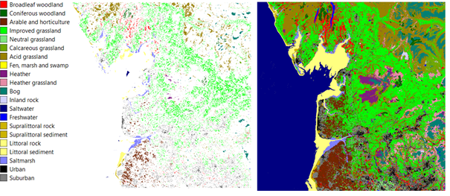
Figure 5. UKCEH Land Cover classes (left), a Bootstrap Training set (centre) and the resultant RF land cover classification (right).

Random Forest classification
Random Forest (RF) classification (Breiman 2001) is a supervised learning technique that uses a training set of known observations to derive an empirical relationship which is then used to predict the membership of unknown observations. Bootstrap Training pixels were placed into labelled bags and from each bag 10,000 samples, with replacement were drawn to train the RF classifier. The RF classifier subsequently yields the 10 m Classified Pixel product (for example, Figure 3, right). Sampling with replacement ensures that all land cover classes have an equal number of pixel observations for training the RF, this balances learning. Without balanced learning the signal of rarer classes will be weak and susceptible to domination from commoner classes, causing misclassification.
The classification software used to produce the UKCEH LCMs is bespoke. It uses Python for the main classification process, including Rapids-AI (RAPIDS Development Team, 2023), numpy (Harris et al., 2020), pandas (the pandas development team, 2026), rioxarray (Snow et al., 2022) and scikit-learn (Pedregosa et al., 2011). For product generation, a PostGIS geospatial database and gdal tools (https://gdal.org/) are used, and the R statistics package (R core team, 2026), including caret (Kuhn, 2008) are used for the final validation.

Product validation
LCM2025 was validated using 33,059 validation reference points collected from across the UK and covering all 21 LCM classes. The reference data is a composite data set, derived from the GB countryside survey, open source National Forest Inventory data, Rural Payment Agency data and a set of bespoke LCM validation points generated from manual image interpretation and field collection. These were intersected with the UKCEH LCM 25 m rasterised polygon datasets to determine correspondence. The overall accuracy of LCM2025 is 86% (Appendix 4).

Known Issues
A small number of polygons are missing from the vector land parcel products, with corresponding areas of nodata in the derived 25 m rasterised land parcels dataset. This will have a negligible effect on the 1 km summary raster data products. The 10 m classified pixels datasets are unaffected.

Citing LCM2025
Each LCM2025 dataset is assigned a DOI and should be cited accordingly. DOIs and citations for the respective datasets are provided in Table 5. Further information on LCM is also available in the LCM data paper (Marston et al. (2023)), which is based on LCM2021, but is relevant for other LCM data sets, including LCM2025.
Table 5: Digital Object Identifier (DOI) and citations for the LCM2025 data products.
Product | Region | DOI | Reference
10 m classified pixels | GB | https://doi.org/10.5285/5beebbfd-a086-464d-9906-280f2b7becb9 | Rowland et al. (2026a)
 | NI | https://doi.org/10.5285/1e39b8ad-430e-4e47-a65a-678d6b995e6a | Rowland et al. (2026b)
25 m rasterised land parcels | GB | https://doi.org/10.5285/995f3744-0f95-426f-9ce7-b2fa729f9f4a | Rowland et al. (2026c)
 | NI | https://doi.org/10.5285/f0c965fc-2db4-4677-87c3-61650aad821b | Rowland et al. (2026d)
Vector land parcels | GB | https://doi.org/10.5285/6376c32c-804e-4517-821e-89a60f83c0cc | Rowland et al. (2026e)
 | NI | https://doi.org/10.5285/7e871d0f-2632-448c-8863-efbb6113923f | Rowland et al. (2026f)
1 km summary raster data | GB and NI | https://doi.org/10.5285/c71ad6f1-200c-4fdf-b946-a2e3923794ee | Rowland et al. (2026g)
UK Land Cover Statistics | UK | https://doi.org/10.5285/73d80e2c-7546-40d8-a734-92fbc57c14f6 | Rowland et al. (2026h)

Acknowledgements
Funding: This research was supported by NERC, through the UKCEH National Capability for UK Challenges Programme NE/Y006208/1.
The authors would like to thank all the data collectors, processors and providers who made this work possible, including the UKCEH data licensing team and the Environmental Information Data Centre team who enable the data sets to reach users. We also thank Jon Cooper and Oladimeji Awe for all their work on the GPU-based Random Forest classification code that now underpinning LCM classifications.
The satellite data provision contains modified Copernicus Sentinel data (2025).
Cartographic and DEM data for NI are from the settlement development limits of the © Northern Ireland Statistics and Research Agency (NISRA) (2015). NI open data layers for coastal water and freshwater are from the © Department of Agriculture, Environment and Rural Affairs, Northern Ireland. OSNI digital elevation data and road network data contain public-sector information licensed under the terms of the Open Government Licence v3.0. Urban green-space correction used green-space areas for NI, identified from OpenStreetMap data provided by OpenStreetMap and available under the Open Database License.
Cartographic data and DEM data for GB are from the digital elevation data of © Intermap Technologies Inc. or its suppliers (2003). OS open data layers contain OS data from © Crown copyright and database right (2015). Field boundaries are from the Rural Payments Agency © Crown copyright and database right and/or © third-party licensors; the Welsh Government, Department of Rural Affairs © Crown copyright and database right and/or © third-party licensors; and the Scottish Government © Crown copyright and database right and/or © third-party licensors. This study contains OS Greenspace data © Crown copyright and database right (2021).
The LCM2025 statistics products use digital boundary products and reference maps, the source of the data is the Office for National Statistics and they are licensed under the Open Government Licence v.3.0. They contain OS data © Crown copyright and database right [2024].
Validation data are from a range of sources:
- the National Forest Inventory (NFI) Woodland GB 2018 data provided by the Forestry Commission and contain Forestry Commission information licensed under the Open Government License v3.0.
- Defra and the Rural Payments Agency are thanked for the access to the IACS Agricultural data and Rural Payment Agency field survey data.
- We thank the Countryside Survey team for provision of the Countryside Survey data. Countryside Survey data are owned by the UK Centre for Ecology and Hydrology.
In addition, we thank Robbie Still of the Kent Wildlife Trust for the provision of the colour-blind friendly palette.
We also thank all those who have been involved in the UK LCM since 1990 as this LCM builds on their hard work.

References
Breiman, L. (2001). Random forests. Machine learning, 45(1), 5-32. https://doi.org/10.1023/A:1010933404324
Carrasco, L., O’Neil, A.W., Morton, R.D. and Rowland, C.S. (2019). Evaluating combinations of temporally aggregated Sentinel-1, Sentinel-2 and Landsat 8 for land cover mapping with Google Earth Engine. Remote Sensing, 11(3), p.288. https://doi.org/10.3390/rs11030288
Feeney, C.J.; Robinson, D.A.; Lawley, R.; Holbrook, H.; Dhiedt, E.; Williamson, J.L.; Tye, A.M.; Redhead, J.W. (2026). National scale maps of parent material properties, terrain and soil natural capital units at 50 metre resolution for Great Britain, 2020. NERC EDS Environmental Information Data Centre. https://doi.org/10.5285/5bcd927d-8114-4937-af7e-258cfd137109
Harris, C.R., Millman, K.J., van der Walt, S.J., Gommers, R., Virtanen, P., Cournapeau, D., Wieser, E., Taylor, J., Berg, S., Smith, N.J., Kern, R., Picus, M., Hoyer, S., van Kerkwijk, M.H., Brett, M., Haldane, A., Fernández del Río, J., Wiebe, M., Peterson, P., Gérard-Marchant, P., Sheppard, K., Reddy, T., Weckesser, W., Abbasi, H., Gohlke, C. and Oliphant, T.E. (2020). Array programming with NumPy. Nature, 585(7825), pp.357-362. https://doi.org/10.1038/s41586-020-2649-2
Jackson D.L. (2000). Guidance on the interpretation of the Biodiversity Broad Habitat Classification (terrestrial and freshwater types): Definitions and the relationship with other classifications, JNCC Report 307, 73 pages, ISSN 0963 8091 (http://www.jncc.gov.uk/page-2433)
Kuhn, M. (2008). Building Predictive Models in R Using the caret Package. Journal of Statistical Software, 28(5), 1 - 26. doi:http://dx.doi.org/10.18637/jss.v028.i05Marston, C. G., O'Neil, A. W., Morton, R. D., Wood, C. M., and Rowland, C. S. (2023). LCM2021 – the UK Land Cover Map 2021, Earth Syst. Sci. Data, 15, 4631–4649, https://doi.org/10.5194/essd-15-4631-2023.
Morton, D., Rowland, C., Wood, C., Meek, L., Marston, C., Smith, G., Wadsworth, R. and Simpson, I. (2011). Final Report for LCM2007-the new UK land cover map. Countryside Survey Technical Report No 11/07.
Pedregosa, F., Varoquaux, G., Gramfort, A., Michel, V., Thirion, B., Grisel, O., Blondel, M., Prettenhofer, P., Weiss, R., Dubourg, V., Vanderplas, J., Passos, A., Cournapeau, D., Brucher, M., Perrot, M., and Duchesnay, E. (2011) Scikit-learn: Machine Learning in Python, JMLR 12, pp. 2825-2830. Online at: https://jmlr.csail.mit.edu/papers/v12/pedregosa11a.html
R Core Team (2026). R: A language and environment for statistical computing. R Foundation for Statistical Computing, Vienna, Austria. URL: https://www.R-project.org/
RAPIDS Development Team (2023) RAPIDS: Libraries for End to End GPU Data Science Team, online at: https://rapids.ai
Rowland, C.S., O’Neil, A.W., Hunt, M.L., and Marston, C.G. (2026a). Land Cover Map 2025 (LCM 2025 - 10m classified pixels, GB). NERC EDS Environmental Information Data Centre. https://doi.org/10.5285/5beebbfd-a086-464d-9906-280f2b7becb9
Rowland, C.S., O’Neil, A.W., Hunt, M.L., and Marston, C.G. (2026b). Land Cover Map 2025 (LCM 2025 - 10m classified pixels, N. Ireland). NERC EDS Environmental Information Data Centre. https://doi.org/10.5285/1e39b8ad-430e-4e47-a65a-678d6b995e6a
Rowland, C.S., O’Neil, A.W., Hunt, M.L., and Marston, C.G. (2026c). Land Cover Map 2025 (LCM 2025 - 25m rasterised land parcels, GB). NERC EDS Environmental Information Data Centre. https://doi.org/10.5285/995f3744-0f95-426f-9ce7-b2fa729f9f4a
Rowland, C.S., O’Neil, A.W., Hunt, M.L., and Marston, C.G. (2026d). Land Cover Map 2025 (LCM 2025 - 25m rasterised land parcels, N. Ireland). NERC EDS Environmental Information Data Centre. https://doi.org/10.5285/f0c965fc-2db4-4677-87c3-61650aad821b
Rowland, C.S., O’Neil, A.W., Hunt, M.L., and Marston, C.G. (2026e). Land Cover Map 2025 (LCM 2025 - land parcels, GB). NERC EDS Environmental Information Data Centre. https://doi.org/10.5285/6376c32c-804e-4517-821e-89a60f83c0cc
Rowland, C.S., O’Neil, A.W., Hunt, M.L., and Marston, C.G. (2026f). Land Cover Map 2025 (LCM 2025 - land parcels, N. Ireland). NERC EDS Environmental Information Data Centre. https://doi.org/10.5285/7e871d0f-2632-448c-8863-efbb6113923f
Rowland, C.S., O’Neil, A.W., Hunt, M.L., and Marston, C.G. (2026g). Land Cover Map 2025 (LCM 2025 - 1km summary rasters, GB and N. Ireland). NERC EDS Environmental Information Data Centre. https://doi.org/10.5285/c71ad6f1-200c-4fdf-b946-a2e3923794ee
Rowland, C.S., Marston, C., and O’Neil, A.W. (2026h). Land Cover Map 2025 (LCM 2025 - UK Land Cover Statistics). NERC EDS Environmental Information Data Centre. https://doi.org/10.5285/73d80e2c-7546-40d8-a734-92fbc57c14f6
Smith, G., Beare, M., Boyd, M., Downs, T., Gregory, M., Morton, D., Brown, N. and Thomson, A. (2007). UK land cover map production through the generalisation of OS MasterMap®. The Cartographic Journal, 44(3), pp.276-283. https://doi.org/10.1179/000870407X241827
Snow, A.D., Brochart, D., Raspaud, M., Bell, R., Chegini, T., Amici, A., Braun, R., Annex, A., Hoese, D., Bunt, F., Ballesteros, G., Hamman, J., Zehner, M., Cordeiro, M., ScottOZ, Henderson, S., Miller, S., The Gitter Badger, Augspurger, T. and pmallas (2022). corteva/rioxarray: 0.10.3 Release (Version 0.10.3) [Computer software]. Zenodo. https://doi.org/10.5281/zenodo.6399263
The pandas development team. (2026). pandas-dev/pandas: Pandas (Version v3.0.5) [Computer software]. Zenodo. https://doi.org/10.5281/zenodo.21500199

Appendix 1. Notes on UKCEH Land Cover Classes
(see also Appendix 2 for a summary of UK BAP Broad Habitat definitions)
Red – highlights updates since LCM2023.
UKCEH Land Cover Class | Notes
Broadleaved woodland | In the UK BAP Broadleaved, mixed and yew woodland the broadleaved woodlands are characterised by stands >5 m high with tree cover >20%. Scrub (<5 m) requires a cover >30 % for inclusion. Such fine distinctions cannot be made through remote sensing. Open-canopy woodland (stands with trees <50 %) is a particular problem, albeit occurring relatively rarely. These are likely to be confused with other classes due to the dominance of the non-woodland understory.  Broadleaved evergreen trees rarely occur in stands >0.5 hectares; an area large enough to create suitable training areas appropriate for classification. Consequently, the classifier would struggle with this land cover. It is likely these stands will be classified as Conifer because of the full-year chlorophyll signal.  Mixed woodland stands of broad-leaved or evergreen trees exceeded the minimum mappable unit, they were treated as separate blocks within the woodland; in many parts of the UK, truly ‘mixed woodlands’ as opposed to those with mosaic-blocks of broadleaved and coniferous trees, are unusual.  Stands with near-closed canopies can be interpreted easily in the field and pure examples can normally be found for training the classifier.  Woodland planted on new sites e.g. former fields, may take up to 10 years before it can be reliably detected in the LCM data set. This is because the canopy needs to become extensive enough to be clearly identified as woodland. Categorisation of young woodland as coniferous/broadleaved woodland is also difficult and will therefore typically be more uncertain than for mature woodland.  In LCM, new woodland on new sites will take longer to detect than harvesting and replanting in an established coniferous plantation (see Coniferous woodland text).
Coniferous woodland | The UK BAP Coniferous Woodland class includes semi-natural stands and plantations, with cover >20 %. Classification of coniferous woodland is generally straightforward, but rare examples of open canopy semi-natural pinewoods are likely to be classified according to the dominant understorey class.  The UK BAP includes new plantation and recently felled areas. These are land use, not land cover. Newly felled areas are often dominated by grass, heather and encroaching vegetation and maybe classified as these, instead of coniferous woodland. However, the LCM methods mean that increasingly LCM accurately classifies harvested and newly planted coniferous woodland, on existing plantation forestry areas, as coniferous woodland. This assumes that coniferous plantations will remain coniferous, but it means that LCM maybe slow to detect change from coniferous plantation forest to other land uses. This maybe a particular issue where large windfarms are being constructed on land previously used for conifer plantations, as habitat restoration means that some of these areas will not return to coniferous woodland. Immature coniferous woodland plantations may also experience misclassification as broadleaved woodland.  LCM is not designed to track harvesting of coniferous plantations.  Deciduous larch has potential for confusion with broadleaved deciduous woodland but is generally correctly identified.
Arable and Horticulture, including bare soil | The BAP Broad Habitat Arable and Horticulture includes annual crops, perennial crops such as berries and orchards and freshly ploughed land. This is a very broad class and as a consequence has large potential for spectral confusion with non-arable surfaces. The main confusion between arable and other classes occurs between arable land and improved grassland. This is especially likely when grassland is managed by cutting, followed by periods of low growth and reflectance from chlorophyll. When this happens the observed seasonal reflectance pattern can be similar to graminid crops, such as wheat and barley. Indeed grass managed in this way is technically a crop, so an arable classification is not necessarily wrong.  Note – this class will also map some bare soil/ground as arable. New developments of houses, commercial/industrial sites and infrastructure often involve periods of bare soil, which will typically be mapped by LCM as arable, whilst the development is underway. In subsequent years, LCM will typically map the land cover as the new class e.g. urban. So, in some cases, it may be appropriate to consider this class as the ‘Arable and Horticulture, including bare soil’ class.  This has not currently been applied to the symbology files distributed with LCM2025.
Improved Grassland | Improved grassland is distinguished from semi-natural grasslands based on its higher productivity, lack of winter senescence, location and/or context. Grasslands lie on a continuum, so some confusion with other grassland types is inevitable. Confusion with grass-like crops will also occur.
Neutral Grassland | The UK BAP Broad Habitat Neutral Grassland is expected to be challenging for satellite-based classification. BAP Neutral Grassland is defined by botanical composition and includes semi-improved grasslands managed for silage, hay or pasture (Jackson, 2000). There is not generally an obvious spectral difference between these and other productive grass types. However, the inclusion of Context Rasters for slope and distance to rivers appear to have helped greatly with Neutral Grassland detection.
Calcareous Grassland | Calcareous Grassland class is mapped spectrally. However, the inclusion of ancillary layers for slope is expected to improve results. UKCEH does not have free access to a highly resolved soil PH/soil type layer, which we would expect to help further. For regions know to contain substantial coverage of Calcareous Grassland, for example Limestone Dales of Derbyshire and North Yorkshire, the South Downs and Salisbury Plain our results match expectations.
Acid Grassland | The UK BAP Acid Grassland can be spectrally variable, depending on dominant species composition. Deciduous Acid grassland, dominated by Molinea caerula has a distinct signal from acid grasslands dominated by mixtures other grasses, rushes, mosses, herbs and sedges. In other work we have been able to refine this class successfully. However, we did not make this separation in historical maps, so we are not able to retrieve suitable observations from Bootstrap Training.  Bracken has a very distinctive spectral signal, but only at certain times of the year when its foliage begins to dominate its grassland understory. Historically, with restricted availability of satellite images we could not reliably separate the UK BAP Bracken class from Acid Grassland so we combined these into a single UKCEH Land Cover Class. With the greater image frequency and therefore better access to seasonal signals it may now be possible to overcome this historic limitation, but to do this we will need novel training data as we will not be able to retrieve a signal from Bootstrap Training.
Heather; and Heather grassland | For LCM2007 we refined the BAP Dwarf Shrub and Heath into two classes, depending on the density of Heather, producing the UKCEH Heather and Heather grassland classes (it is heather when there is greater than 25 % Heather cover). This was to retain some consistency between the LCM1990 and LCM2000 classes Open Shrub Heath and Dense Shrub Heath. In some parts of the UK, significant areas of low-lying non-heather shrubs occur. For example, Gorse can form a dominant shrub layer.  Note: the Land Cover Maps typically show confusion over Heather, Heather grassland and Bog. However, they are often difficult to separate in the field. It is challenging to accurately estimate coverage above and below the defining threshold.
Fen, Marsh and Swamp | The UK BAP Fen, Marsh and Swamp includes fen, fen meadows, rush pasture, swamp, flushes and springs. From a remote sensing perspective Fen, Marsh and Swamp is problematic as it is can be comprised of a wide range of vegetation types and many patches are below the MMU of the UKCEH Land Parcel Spatial Framework. The small size of many Fen, Marsh and Swamp patches, plus their typically mosaic nature make it difficult to find reliable training data. Consequently, Fen, Marsh and Swamp is likely to be underestimated in some regions. However, substantial areas of contiguous reed dominated Fenland appear to be well detected.
Bog | The UK BAP Bog includes ericaceous, herbaceous and mossy swards in areas with a peat depth >0.5 m. We cannot detect peat depth from satellites.  Vegetation on deep peat soils represent a continuum involving acid grassland, dwarf shrub heath and some types of fen, marsh and swamp and the separation of continuously varying land cover into discrete types can be difficult, especially when they exist in a complex small patch mosaic and their definitions are vague.  We retain the Bog class to maintain consistency with historical UKCEH LCM products and the RF classifier learns Bog presence based on training data automatically generated from these. The predicted distribution occurs in regions where it is expected, so is a good indicator of where Bog is likely to be occurring. However, Bog and the range of upland vegetation classes expected to occur on peaty soils (Acid grassland, Fen marsh and swamp, Heather, and Heather grassland) show a cluster of interclass confusion (Appendix 4). This is partly due fine-scale variation but largely an effect of ambiguous definitions. UK BAP Broad Habitats (on which UKCEH Land Cover Classes are based) were not defined with satellite remote sensing in mind.
Saltwater | Saltwater is rarely different spectrally from freshwater, and the saltwater distribution predicted by the RF classifier is determined by coastal Context Rasters in Classification Scenes. There will be some confusion between Saltwater and Freshwater in tidal rivers, but not substantial. Occasionally, Saltwater is confused with non-vegetated surfaces close to the coast and this happens because the automatically generated Saltwater training classes coincide with low-tide conditions in the satellite view. The effect has so far been trivial but the result is that we predict Saltwater with slightly lower accuracy than Freshwater.
Freshwater | The UKCEH Freshwater class comes from merging two BAP BHs (Standing Open Water and Canals, and Rivers and Streams) since they cannot be separated by spectra. In many cases, small and/or narrow water bodies fall below the MMU of the UKCEH Land Parcel Spatial Framework so effectively disappear into the dominant surrounding vegetation. Where these features are appropriately aligned and sufficiently wide, pixels they may be detected and if so will be available in the Raster Classification datasets.  Water bodies >0.5 ha and wider than 40 m are mapped with very high accuracy. The exceptions are temporary water bodies and quarries. Water in some quarries is strongly affected by the minerals in the rock and can result in atypical colours and misclassification.
Inland Rock | The BAP Broad Habitat Inland Rock covers both natural and artificial exposed rock surfaces which are >0.25 ha, such as inland cliffs, caves, screes and limestone pavements, as well as various forms of excavations and waste tips such as quarries and quarry waste. Opportunistic vegetation is common amongst rocky landscapes. We classify UKECH Inland Rock if rock has the dominant signature.
Urban; and Suburban | Within the Built-up Areas and Gardens BAP Broad Habitat we can reliably separate two UKCEH categories: Urban and Suburban. Urban includes dense urban, such as town and city centres, where there is little, if any, vegetation. Urban also includes areas such as dock sides, car parks and industrial estates. It is sometimes confused with other non-vegetated surfaces; for example open cast quarries or more rarely coastal rocks or ploughed fields.  Suburban includes suburban areas where the spectral signature is a mix of urban and vegetation signatures. Suburban and Urban lie on a continuum and confusion is expected.
Supralittoral Rock | Features that may be present in this coastal class include vertical rock, boulders, gullies, ledges and pools generally forming a narrow band when viewed from above. Only limited areas can be mapped using satellite remote sensing.
Supralittoral Sediment | This class includes sand dunes, which are reliably mapped. Areas of coastal sand may be confused between this class and the littoral sediment class. Supralittoral sediments can stabilise and from increasing volumes of vegetation. Heavily vegetated littoral sediment is likely to be classified as a vegetation class.
Littoral Rock | These classes are those in the maritime zone on a rocky coastline. They are generally more extensive than supralittoral rock and thus more readily detected using satellite images.
Littoral Sediment; and Saltmarsh | The BAP Broad Habitat Littoral Sediment has a subclass, the BAP Priority Habitat Saltmarsh. Saltmarsh is generally distinct from nearby vegetation and only occurs near the coast, so we can map this well with remote sensing. The Littoral Sediment is sometimes confused with the Supralittoral Sediment class.

Appendix 2. Biodiversity Action Plan (BAP) Broad Habitats
This appendix provides a brief summary of the JNCC definitions of the Broad Habitats and is based on Jackson (2000). There is some duplication of material Appendix 2 with Appendix 1. However in combination they provide users with key information to understand UKCEH Land Cover Classes and the Broad Habitat definitions they are based on. Note: class numbers here are JNCC’s Broad Habitat class numbers, not UKCEH Land Cover Class numbers.
The text in this Appendix has been copied from Morton et. al., 2011, with very minor updates to remove obsolete cross-references to historical projects and documents, plus some corrections. Some new comments are included regarding BAP Broad Habitat Linear Features and the 10 m Classified Pixel datasets.

1. Broadleaved, Mixed and Yew Woodland
This Broad Habitat is characterised by vegetation dominated by trees >5 m high when mature, with tree cover >20 %. Scrub (<5 m) requires cover >30 % for inclusion in this Broad Habitat. It includes stands of both native and non-native broadleaved trees and yew. Woodlands dominated by coniferous species but with >20 % cover by deciduous species are included in this category. Areas of fen woodland dominated by species such as willow (Salix spp.), alder (Alnus glutinosa) or birch (Betula spp.) are also included.

2. Coniferous Woodland
This Broad Habitat is characterised by vegetation dominated by trees >5 m high when mature, which forms a canopy having a cover of >20 %. ‘Coniferous Woodland’ includes semi-natural stands and plantations and includes both native and non-native coniferous trees.

3. Boundaries and Linear Features
This Broad Habitat type covers a range of linearly arranged landscape features such as hedgerows, lines of trees, walls, stone and earth banks, grass strips and dry ditches. These features are not included as a UKCEH Land Cover Class as they are generally too narrow to be reliably captured from the satellite images. However, linear features are of general interest and an important component of the landscape. Some linear features may be visible in the 10 m Classified Pixel dataset.

4. Arable and Horticulture
This Broad Habitat includes annual crops, perennial crops, woody crops, intensively managed commercial orchards, commercial horticultural land (such as nurseries, commercial vegetable plots and commercial flower growing areas), freshly-ploughed land, annual leys, rotational set-aside and fallow.

5. Improved Grassland
‘Improved Grassland’ is characterised by vegetation dominated by a few fast-growing grasses such as Lolium spp., and also white clover (Trifolium repens), on fertile, neutral soils. Improved grasslands are typically either managed as pasture, or mown regularly for silage production or in non-agricultural contexts for recreation and amenity purposes.

6. Neutral Grassland
This Broad Habitat type is characterised by vegetation dominated by grasses and herbs on a range of neutral soils usually with a pH of between 4.5 and 6.5. It includes enclosed dry hay meadows and pastures, together with a range of grasslands which are periodically inundated with water or permanently moist.

7. Calcareous Grassland
Calcareous Grassland is characterised by vegetation dominated by grasses and herbs on shallow, well-drained soils which are rich in bases (principally calcium carbonate) formed by the weathering of chalk and other types of limestone or base-rich rock. Soil pH tends to be high (>6) although it may be as low as 5.

8. Acid Grassland
Acid Grassland is characterised by vegetation dominated by grasses and herbs on a range of lime-deficient soils, which have been derived from acidic bedrock or from superficial deposits such as sands and gravels. Such soils usually have a low base status, with a pH of <5.5.

9. Bracken
This Broad Habitat type covers areas dominated by a continuous canopy cover of bracken (Pteridium aquilinum) at the height of the growing season. It does not include areas with scattered patches of bracken or areas of bracken, which are less than 0.25 ha. These are included in the Broad Habitat type with which they are associated.

10. Dwarf Shrub Heath
‘Dwarf Shrub Heath’ is characterised by vegetation that has >25 % cover of plant species from the heath family (ericoids) or dwarf gorse Ulex minor. It generally occurs on well-drained, nutrient-poor, acid soils. This habitat type does not include dwarf shrub dominated vegetation in which species characteristic of peat-forming vegetation such as cotton grass Eriophorum spp. and peat-building sphagna are abundant, or that occurs on deep peat (>0.5 m) as these are included in the 'Bog' Broad Habitat type.

11. Fen, Marsh and Swamp
This habitat includes fen, flushes, springs, fen meadows, rush pasture and swamp. Fens are peatlands that receive water and nutrients from groundwater and surface runoff, as well as from rainfall. Flushes are associated with lateral water movement, and springs with localised upwelling of water. Marsh is a general term usually used to imply waterlogged soil; it is used more specifically here to refer to fen meadows and rush-pasture communities on mineral soils and shallow peats. Swamps are characterised by tall emergent vegetation. Reedbeds (i.e. swamps dominated by stands of common reed Phragmites australis) are also included in this type. Apart from rush pasture, examples of this Broad Habitat are relatively rare.

12. Bog
This Broad Habitat type covers wetlands that support vegetation that is usually peat-forming and which receive mineral nutrients principally from precipitation rather than ground water. This is referred to as ombrotrophic (rain-fed) mire. The Bog Broad Habitat includes ericaceous, herbaceous and mossy swards in areas with a peat depth >0.5 m.

13. Standing Open Water and Canals
This Broad Habitat type includes natural systems such as lakes, meres and pools, as well as manmade waters such as reservoirs, canals, ponds and gravel pits.

14. Rivers and Streams
The 'Rivers and Streams' Broad Habitat type covers rivers and streams from bank top to bank top, or where there are no distinctive banks or banks are never overtopped, it includes the extent of the mean annual flood.

15. Montane
The ‘Montane Habitats’ category includes a range of vegetation types that occur exclusively in the montane zone such as prostrate dwarf shrub heath, snow-bed communities, sedge and rush heaths, and moss heaths. The distinction between the sub-montane and montane zone is often blurred and the two usually merge through a band of transitional vegetation.

16. Inland Rock
This Broad Habitat type covers both natural and artificial exposed rock surfaces which are >0.25 ha, such as inland cliffs, caves, screes and limestone pavements, as well as various forms of excavations and waste tips such as quarries and quarry waste.

17. Built-Up Areas and Gardens
This Broad Habitat type covers urban and rural settlements, farm buildings, caravan parks and other manmade built structures such as industrial estates, retail parks, waste and derelict ground, urban parkland and urban transport infrastructure. It also includes domestic gardens and allotments. This type does not include amenity grassland, which should be included in the 'Improved Grassland' category.

18. Supralittoral Rock
This habitat occurs above the high water mark, in areas influenced by wave splash and sea spray. Features that may be present include vertical rock, boulders, gullies, ledges and pools, depending on the wave exposure of the site and its geology.

19. Supralittoral Sediment
This habitat occurs above the high water mark, but in areas influenced by wave splash and sea-spray. It includes shingle beaches, sand dunes and machair.

20. Littoral Rock
The geology and wave exposure of the shore influence the form of Littoral Rock habitats, which can be as varied as vertical rock, shore platforms, boulder shores, or rocky reefs surrounded by areas of sediment. In general, Littoral Rock tends to be colonised by algae in wave-sheltered conditions, and by limpets, barnacles and mussels as wave-exposure increases.

21. Littoral Sediment
Areas of Littoral Sediment are widespread around the UK forming features such as beaches, sand banks, and intertidal mudflats. A large proportion of this habitat occurs in estuaries and inlets where it can cover extensive areas. Saltmarsh is included within this Broad Habitat.

22. Inshore Sublittoral Sediment
All areas of sea and estuary class are assumed to be Inshore Sublittoral Sediment. It is defined as within six nautical miles of the shoreline by JNCC.

Appendix 3. Full list of datasets for UKCEH LCM2025

 | Dataset | Land mass | Full Citation
UKCEH LCM2025 | 10 m Classified Raster Product | Great Britain | Rowland, C.S., O’Neil, A.W., Hunt, M.L., and Marston, C.G. (2026a). Land Cover Map 2025 (LCM 2025 - 10 m classified pixels, GB) https://doi.org/10.5285/5beebbfd-a086-464d-9906-280f2b7becb9
UKCEH LCM2025 | Land Parcel Product | Great Britain | Rowland, C.S., O’Neil, A.W., Hunt, M.L., and Marston, C.G. (2026e). Land Cover Map 2025 (LCM 2025 - land parcels, GB) https://doi.org/10.5285/6376c32c-804e-4517-821e-89a60f83c0cc
UKCEH LCM2025 | 25 m Rasterised Land Parcel Product | Great Britain | Rowland, C.S., O’Neil, A.W., Hunt, M.L., and Marston, C.G. (2026c). Land Cover Map 2025 (LCM 2025 - 25 m rasterised land parcels, GB) https://doi.org/10.5285/995f3744-0f95-426f-9ce7-b2fa729f9f4a
UKCEH LCM2025 | 10 m Classified Raster Product | Northern Ireland | Rowland, C.S., O’Neil, A.W., Hunt, M.L., and Marston, C.G. (2026b). Land Cover Map 2025 (LCM 2025 - 10 m classified pixels, N. Ireland) https://doi.org/10.5285/1e39b8ad-430e-4e47-a65a-678d6b995e6a
UKCEH LCM2025 | Land Parcel Product | Northern Ireland | Rowland, C.S., O’Neil, A.W., Hunt, M.L., and Marston, C.G. (2026f). Land Cover Map 2025 (LCM 2025 - land parcels, N. Ireland) https://doi.org/10.5285/7e871d0f-2632-448c-8863-efbb6113923f
UKCEH LCM2025 | 25 m Rasterised Land Parcel Product | Northern Ireland | Rowland, C.S., O’Neil, A.W., Hunt, M.L., and Marston, C.G. (2026d). Land Cover Map 2025 (LCM 2025 - 25 m rasterised land parcels, N. Ireland) https://doi.org/10.5285/f0c965fc-2db4-4677-87c3-61650aad821b
UKCEH LCM2025 | 1 km Summary Rasters | Northern Ireland and Great Britain | Rowland, C.S., O’Neil, A.W., Hunt, M.L., and Marston, C.G. (2026g). Land Cover Map 2025 (LCM 2025 - 1 km summary rasters, GB and N. Ireland) https://doi.org/10.5285/c71ad6f1-200c-4fdf-b946-a2e3923794ee
UKCEH LCM2025 | Spatial and tabular statistics | UK | Rowland, C.S., O’Neil, A.W., Hunt, M.L., and Marston, C.G. (2026h). Land Cover Map 2025 (LCM 2025 - UK Land Cover Statistics) https://doi.org/10.5285/73d80e2c-7546-40d8-a734-92fbc57c14f6

Appendix 4. Correspondence matrices for UKCEH LCM2025
(green cells highlight perfect correspondence)
Overall Statistics - Accuracy : 0.8592, 95% Confidence Interval : (0.8554, 0.8629)
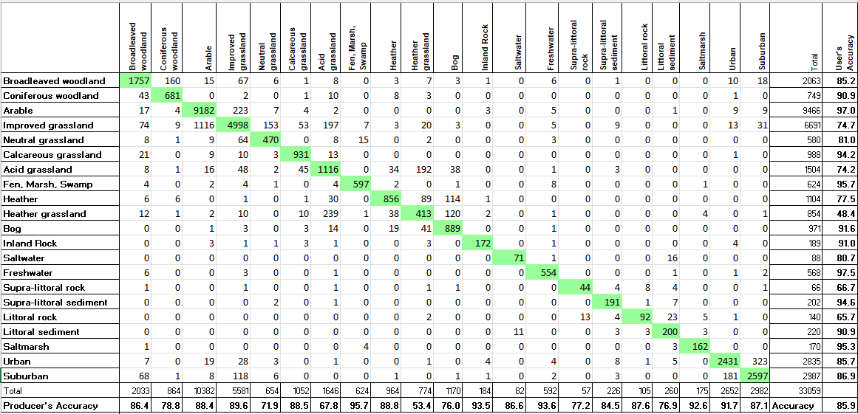

Appendix 5. Traditional colour recipe for displaying UKCEH Land Cover Classes

UKCEH Land Cover Class | UKCEH Land Cover Class number | Red | Green | Blue
Broadleaved woodland | 1 | 255 | 0 | 0
Coniferous Woodland | 2 | 0 | 102 | 0
Arable and Horticulture | 3 | 115 | 38 | 0
Improved Grassland | 4 | 0 | 255 | 0
Neutral Grassland | 5 | 127 | 229 | 127
Calcareous Grassland | 6 | 112 | 168 | 0
Acid grassland | 7 | 153 | 129 | 0
Fen, Marsh and Swamp | 8 | 255 | 255 | 0
Heather | 9 | 128 | 26 | 128
Heather grassland | 10 | 230 | 140 | 166
Bog | 11 | 0 | 128 | 115
Inland Rock | 12 | 210 | 210 | 255
Saltwater | 13 | 0 | 0 | 128
Freshwater | 14 | 0 | 0 | 255
Supralittoral Rock | 15 | 204 | 179 | 0
Supralittoral Sediment | 16 | 204 | 179 | 0
Littoral Rock | 17 | 255 | 255 | 128
Littoral sediment | 18 | 255 | 255 | 128
Saltmarsh | 19 | 128 | 128 | 255
Urban | 20 | 0 | 0 | 0
Suburban | 21 | 128 | 128 | 128

To display the 21-class raster products (specifically the 10 m, 25 m and 1 km dominant target class products) QGIS and Arc symbology files are provided alongside the respective data product (QGIS: lcm_raster_21class.qml, Arc: LCM2017-2024_raster.lyr). The symbology file contains the traditional colour recipe for displaying UKCEH land cover classes as given above. Vector symbology files (QGIS: lcm_vector.qml, Arc: LCM2017-2024_parcel.lyr ) are also provided for the vector data set.
No colour palettes are currently provided for the 1 km aggregate class products, or the 1 km percentage products.

Appendix 6. Recommended colour recipe for displaying UKCEH Land Cover Classes colour blind friendly

UKCEH Land Cover Class | UKCEH Land Cover Class number | Red | Green | Blue
Broadleaved woodland | 1 | 51 | 160 | 44
Coniferous Woodland | 2 | 0 | 80 | 0
Arable and Horticulture | 3 | 240 | 228 | 66
Improved Grassland | 4 | 1 | 255 | 124
Neutral Grassland | 5 | 220 | 153 | 9
Calcareous Grassland | 6 | 255 | 192 | 55
Acid grassland | 7 | 178 | 145 | 0
Fen, Marsh and Swamp | 8 | 253 | 123 | 238
Heather | 9 | 128 | 26 | 128
Heather grassland | 10 | 230 | 140 | 166
Bog | 11 | 205 | 59 | 181
Inland Rock | 12 | 210 | 210 | 255
Saltwater | 13 | 0 | 0 | 92
Freshwater | 14 | 0 | 0 | 255
Supralittoral Rock | 15 | 152 | 125 | 183
Supralittoral Sediment | 16 | 204 | 179 | 0
Littoral Rock | 17 | 255 | 255 | 128
Littoral sediment | 18 | 255 | 255 | 128
Saltmarsh | 19 | 128 | 128 | 255
Urban | 20 | 0 | 0 | 0
Suburban | 21 | 128 | 128 | 128

To display the 21-class raster products (specifically the 10 m, 25 m and 1 km dominant target class products) QGIS and Arc symbology files are provided alongside the respective data product (QGIS: lcm_raster_cb_friendly_21class.qml, Arc: LCM2017-2025_raster_cb_friendly.lyr). The symbology file contains a colour blind-friendly colour palette for displaying UKCEH land cover classes as given above. A symbology file for QGIS (lcm_vector_cb_friendly.qml) is also provided for the vector data set.
No colour palettes are currently provided for the 1 km aggregate class products, or the 1 km percentage products.

